**Similar representation of names and faces in the network for person perception.**

**Highlights**

* Face perception and name reading engage overlapping regions in the extended system
* Knowledge is represented stably in the extended system, regardless of input modality
* Three cluster model explains task encoding

**Abstract**

Person-knowledge encoded a wide repertoire of diverse knowledge we have about conspecifics. This knowledge spans social, physical, episodic, semantic & nominal knowledge. Accessing person-knowledge cued from faces and names recruits largely overlapping brain regions in the extended system. Whether the brain uses same or different mechanisms to extract knowledge from faces and written names is unclear. In this paper, we use representational similarity analysis adapter to look for network level patterns of similarity (netRSA). We demonstrate the way person knowledge is encoded in the extended system is similar across modalities of presentation in the extended, but not core systems. Further modelling shows hierarchical organisation of person knowledge, 10 broad tasks form 3 distinct clusters socio-perceptual judgements, episodic-semantic memory.

**Introduction**

**Bullet Points**

* Person knowledge is a type of conceptual knowledge
  + interesting to investigate because stimulating person-identity brings into awareness all kinds of conceptual knowledge (social, nominal, episodic, biographical, physical).
* Traditionally investigated using faces, (haxby core/extended)
  + Previously we demonstrated that person-knowledge is spread out across the whole network. Diverse domains engaged most-all extended system regions, task differed in pan-network pattern that they elicit. Broadly cognitions formed three clusters:
* Person knowledge can also be accessed via names: in terms of the organisation of knowledge domains and the functionally coordinating sub-elements of the network, we observed during face viewing truly reflect person knowledge they should persist when we use names instead of faces.
* This paper investigates how person-knowledge is organised, and uses names as stimuli
  + We use netRSA to see the similarities between person knowledge domains, and to see similarities in functional behavioural of regions.
  + We *additionally* make use of the fact that we ran the same experiment with faces to see how these structures are similar across different presentation modalities

**Person knowledge**

Ability to identify known people in our lives is a crucial. To efficiently communicate with conspecifics, we need to recognise the identity of the individual, and combine broad kinds of information we have associated with them (memories, facts, social information & their names). This process is fast and effortless, however the neural mechanisms behind it are still unclear.

**Common systems for faces and names**

Prior work has suggested that some regions involved in person-knowledge respond might be amodal, i.e. respond to both picture and written name stimuli. Gorno-Tempini et al (1996) contrasted brain activity while people performed a simple (1-back matching) task while viewing faces or reading names for familiar and unfamiliar people. Results showed that while both stimulus modalities faces and names elicit activity in respective regions associated with perceptual processing (fusiform for faces, and left STS for names). Both modalities also excited activity in common areas associated with semantic knowledge - anterior ATL, IFG Precuneus & vmPFC. Nielson et al (2010) found concurrent results,

**Words vs Pictures**

Investigating commonalities between words and pictures is important for investigating semantics. Semantic representation should the same, regardless of modality of presentation.  in an fMRI experiment, Devereux et al (2014) presented object concepts in two modalities (words and pictures)  and used RSA to reveal where concepts are grouped based on their semantic category, regardless of stimulus modality. Authors found that only some regions responded to both picture and word stimuli, but their representation spaces were not amodal. pMTG for example was sensitive to semantic category for both picture and words, but was not amodal - there was a difference between picture and words RDMs. LIPS on the other hand, had cross-modal multi-voxel patterns. This is to show that if a region responds to both pictures and names, the response is not necessarily amodal.

**Patient studies**

Person-knowledge cued by faces and names can be differentially impaired. Haslam, Cook & Coltheart (2001) reported a patient TG with retrograde anmesia. Even though this patient could recognise both names and faces, he was able to access more semantic information (biographical facts) when cued with names, and less when cued with faces. McCarthy and Warrington (1992) describe a patient RFR, who performed normally on familiarity tasks with both names and faces, but when accessing semantic information (such as occupation), was able to recall more facts when cued with names.  VH, described by Evans *et al.* (1995) was able to provide factual information for famous people when cued with names (for 39/50 famous people), but not when cued with faces (11/50). These findings challenge exist accounts that semantic stores are acesses equally by all modalities of stimulus, and suggest unequal access to semantic stores of person-knowledge.

**Person-knowledge**

Same cues for person knowledge retrieval can prompt different mechanisms. Consider judging persons trustworthiness. Accounts suggest that we use facial cues, such as face typicality to decide if someone is trustwothy (Sofer et al., 2014). However, other accounts, such as Todorov & Duchaine (2008) suggest that patients with prosopagnosia judge same unknown faces as trustworthy as do healthy subjects, suggesting that they tap into the same cognitive mechanisms, regardless of perceptual abilities.

in an MEG experiment, Leonardelli et al (2018) showed that accessing person knowledge (nationality) evokes common patterns of brain activity.

* + Does stimulus type (faces/names) change how these cognitions are encoded?
* Is person knowledge represented the same during reading?

**Current Experiment**

In this experiment, to see whether person-knowledge is represented stably across modalities we ask participants to recall 10 different types of knowledge spanning 5 domains (social, physical, episodic, biographical & nominal).

By looking at network-level, multivariate response similarity patterns we can see how

**Methods**

**Participants**

31 participants took part in this study (mean age M = 24.74, SD = 3.13). All participants had normal or corrected to normal vision and were free from neurological disorders. Study was approved by the University of Trento Ethical committee. Participants were compensated for their time. Seven participants were removed from analysis: Two participants did not complete the experiment due to technical issues with the stimulation computer, data from five participants was removed due to excessive motion in the scanner.

**Stimuli**

Stimuli were 40 names of recognisable famous people (politicians, actors, athletes or businesspeople). Person’s first and last names were presented in large font on separate lines. Mean name length (first name + last name) was M = 12.15, SD = 2.59 letters. For monuments control task, stimuli were names of familiar places ("Notre Dame”, “Piramidi di Ghiza”, etc.). People and monument names did not differ in overall length (t(78) = 0.30,p = 0.768, independent samples t-test).

**Task**

Each experimental block started with 4s instruction screen specifying the task, followed by 6s of fixation cross. After that a name was presented for .5s followed by 2s of fixation cross during which subjects provided a response via button box. Within each 8-trial block, participants were instructed to respond to questions covering five categories of person knowledge: episodic memories, semantic knowledge, social judgments, nominal knowledge and physical knowledge. For each of the categories, we chose two different probe questions that require access to each kind of knowledge (totalling ten experimental tasks; see Figure x and Table x). In addition, there were two 1-back matching control tasks with either names of people or monuments. The experiment consisted of five runs (8 min, 42s each). Sixteen blocks were presented in a randomised order (one block for each task plus three face and three monument 1-back control blocks). Participants responded with a button box provided. For 9/10 tasks rating scale was inverted modified Likert scale (1 - strongly agree with task statement, 2 - somewhat agree, 3 - little agreement, 4 -least agreement). Occupation question (“what is this persons’ occupation”) had predefined categories (1 = actor or TV presenter, 2 = singer or musician, 3 = politician or sportsman, 4 = other or none of the above). Prior to scanning, participants practiced answering experimental questions on a different set of famous people repeating each question for five trials.

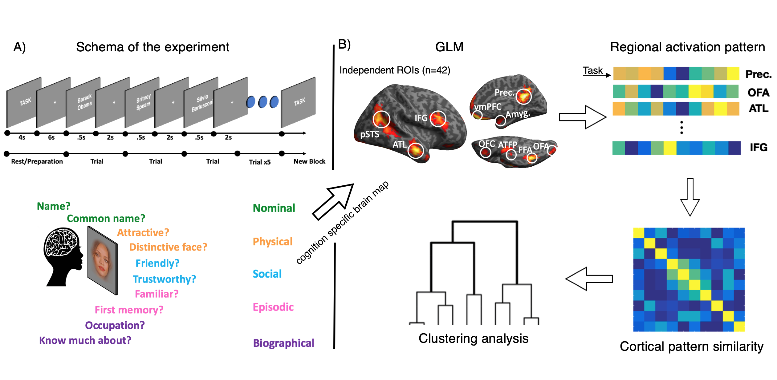

Figure (). Experimental and data analysis procedures. A) Schematic of the fMRI experiment.

B) Task specific response estimates (beta values) for each task were extracted from independently defined, face-selective ROIs. This resulted in a 10 value vector (each value representing response magnitude for each person-knowledge task).

Table 1. Task description. For each of the five person-knowledge domains sampled we choose two probe questions, totalling ten experimental conditions.

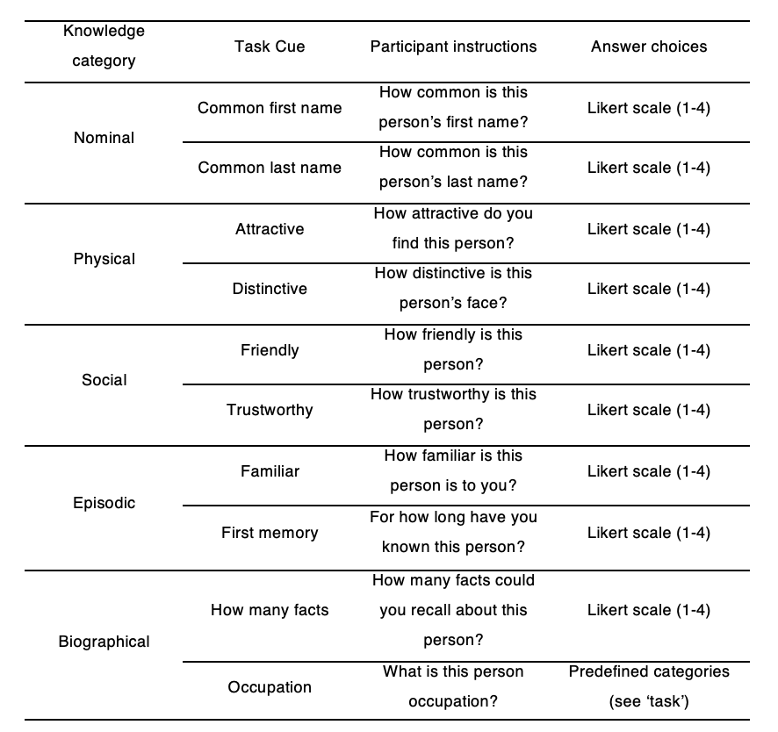

**Data Acquisition**

Participants were scanned at the Center for Mind/Brain Sciences (CIMeC), University of Trento, Italy. Data was collected using Bruker BioSpin MedSpec 4T, with 8-channel phased-array head coil. Five runs of 209 echo-planar volumes, consisting of 34, AC-PC aligned axial slices were acquired while participants performed the task (FOV = 64mm x 64mm, TR = 2.5s, TE = 33, FA = 73°). Voxel size was 3x3x3mm with a 1mm gap. In addition to functional data, a whole brain T1 MPRAGE anatomical image was acquired (whole brain (FOV = 256x224, 176 1mm axial slices).

**Regions of Interest**

Regions of interest (ROIs) were selected from an independent (N=42) experiment, conducted for high power functional localisation. In the localiser experiment participants performed a 1-back matching task with 12 second blocks of famous faces, common animals or common objects. The contrast faces >animals+tools (p < .05 FWE corrected) was used to identify face selective peaks (Table 2)**.**  7.5mm radius spheres were drawn around the peak voxels and task evoked brain responses (beta estimates) were extracted for each subject.

Table 1. ROI sphere centre coordinates. Peak coordinates for regions active in the localiser experiment (N=42) and ROI sizes in voxels after thresholding. Coordinates are in MNI space.

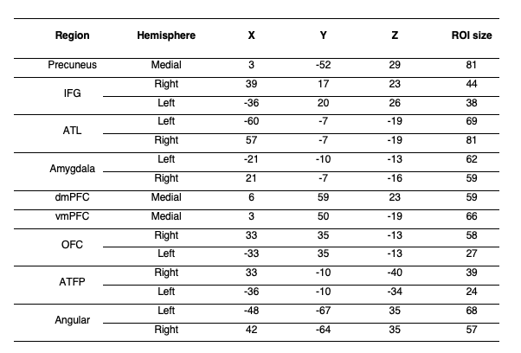

**Data Analysis**

Data were pre-processed with SPM12. Functional images were realigned to account for motion, grey matter segmented, warped into common space and smoothed with 8mm FWHM kernel. Subject specific response estimates (beta weights) were derived by fitting a general linear model (GLM) to the data. 12 regressors (10 tasks, 2 controls) were included as explanatory variables. Six motion parameters from re-alignment procedure were included as regressors of no interest.

To mediate anatomical specificity and signal strength, we drew 7.5mm radius spheres around the chosen coordinates (diameter = 5 voxels (voxel size 3mm3)); We then extracted the mean beta value from voxels within those ROIs that were significantly active at p < 0.001 (contrast faces > animals+tools, see Table 3 for location and extent). To baseline the cognitive response with respect to perceptual effects elicited by viewing reading names, within each region, the activation from the control condition was subtracted from task activation. Activity during the experimental (person knowledge) tasks did not factor in the localisation procedure.

**Multivariate Analyses & RSA Models**

ROI responses across tasks were averaged across voxels and correlated to obtain a dissimilarity matrix (1-*r*), which was then subjected to Ward hierarchical agglomerative clustering. For task similarity analysis the matrix was transposed before correlating so that similarity matrix consisted of task correlation across ROIs.

To build independent models of task and ROI similarity, an almost identical experiment was performed with an independent group of subjects (N=20) using faces instead of names as stimuli (Aglinskas & Fairhall, 2019). Task and ROI Similarity matrices (figures x, y) from the face experiment were used as RSA models, and compared with respective similarity structures in the current experiment, in a standard RSA model comparison framework (Kriegeskorte, Mur & Bandettini, 2008).

**Results**

**Behavioural Results**

Average reaction times(RT) across all task was M = 630msec, SD = 122msec. Participants responded the fastest during attactiveness judgements (M = 577msec  SD =120msec), and slowest during ‘last name’ task (693msec SD = 176msec). Reaction times differed across ten tasks F(4.7,84.6) = 4.04, p = .003 (Greenhouse-Geisser corrected), but not across task domains F(4,72) = 1.83, p = .132. To verify participants’ knowledge about stimulus people, we look into their in-scanner behavioural responses. Response ratings indicated subjects’ agreement with task statement (e.g. is this person familiar to you): 1 - very much, 2 - a lot, 3 - somewhat 4 - very little. Mean rating across all tasks was M = 2.4, SD = .25, indicating that most answers were fell between ‘a lot’ and ’somewhat’. When asked specifically about familiarity, M = 87% SD = 8.2% indicated at least some degree of familiarity with the stimulus person (between 3 - ‘little’ to 1 - ‘very much’). M = 81% SD = 10% subjects indicated that they knew at least few facts about the person. Participants correctly identified the occupation of M = 82%, SD = 15% of people, indicating high levels of knowledge about people presented.

**Whole brain analysis**

We first investigate whole brain activations during person knowledge tasks. Contrasting all tasks over name matching control tasks, revealed a broad network of regions involved in accessing name-cued person knowledge. Consistent with previous literature, areas involved theory of mind -  AG, Prec, vmPFC and dmPFC and left ATL are recruited. Large portions of frontal love, as well as left motor/premotor cortices can be seen active. To further investigate person-knowledge representation in these regions, we extract response magnitudes for each task, from face-selective ROIs defined on an independent dataset.

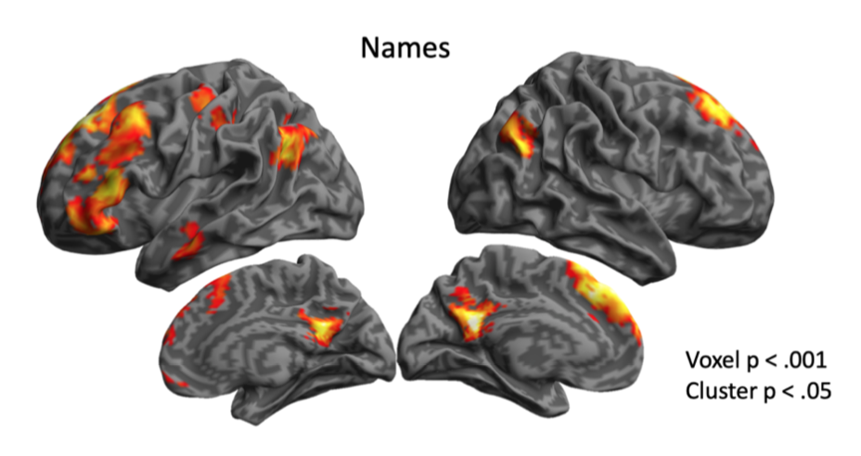

*Figure 1. Whole brain map showing regions more active during person knowledge tasks than 1-back famous person name matching task. Some regions associated with internalised cognition (Precuneus, dmPFC, vmPFC, left ATL, bilateral AG) are robustly activated. Activity in other key regions (amygdala, ATFP) did not survive cluster correction.*

**Region of interest analyses**

To confirm whether accessing person knowledge by reading famous names engaged the extended system ROIs we average across all domains of person knowledge, and subtract the activity during 1-back famous person name matching task. Results show a strong laterality effect in some regions. While AG and OFC responded strongly to person knowledge demands bi-laterally - IFG, Amy & ATL responded more strongly on the left than the right hemisphere.

Left amygdala was recruited during person knowledge retrieval, but only at an uncorrected threshold. Anterior temporal face patch (ATFP) on average was not responsive to person-knowledge demands (but see next section: cognitive tuning). Medial structures (Precuneus, dmPFC, vmPFC) were strongly engaged by person knowledge demands, responding more than during 1-back matching task.

Overall, regions of extended system for face-perception are involved, when participants read names of famous people.

map

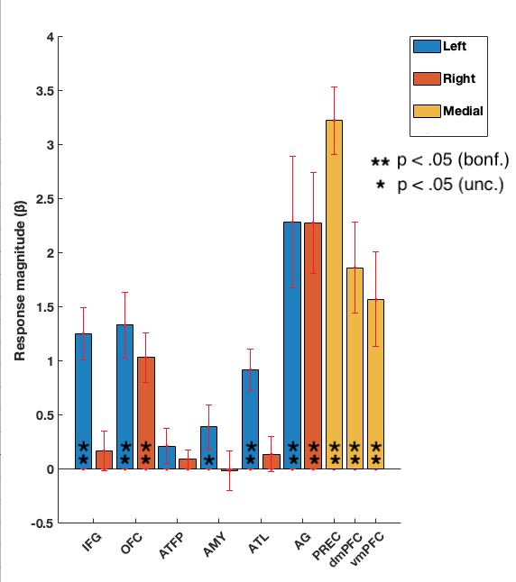

*Figure 2. Extended system ROI involvement in person knowledge during name reading. Independently defined ROI active during face viewing tend to be active during name reading as well.*

**Regional cognitive tuning**

[task x hemisphere interactions?]

Next we look at whether regions have cognitive preferences. To visualise the graded importance of different cognitive domains for a particular region - we scale each regions domain-specific response, by the total (summed) response across all five domains (figure).  Regions differ in terms of to which tasks they respond. Some regions, like the precuneus respond robustly to all tasks (all t > x, all p < .001). Some others are tuned to particular tasks. Angular gyrus showed robust response response to all tasks (all p < .05). However, this region preferentially responded more to episodic knowledge than to any other tasks (all t > 3.56, all p < .002 (unc)). Episodic knowledge preference holds true for both left and right hemisphere homologues. We interrogated hemisphere differences 2 by 5 repeated measures ANOVA. There was a main effect of task domain F(x,x) = 6.929, p < .001, no effect of hemisphere.

[add ATL preference for social; stats]

Overall, regions differ in terms of which kinds of person-knowledge they preferentially respond to. But instead of being specialised for one specific domain, regions respond to multiple (in some cases all domains) with graded pattern of preference. Next we investigate groups of regions sharing similar cognitive tunings as well as structure of person-knowledge.

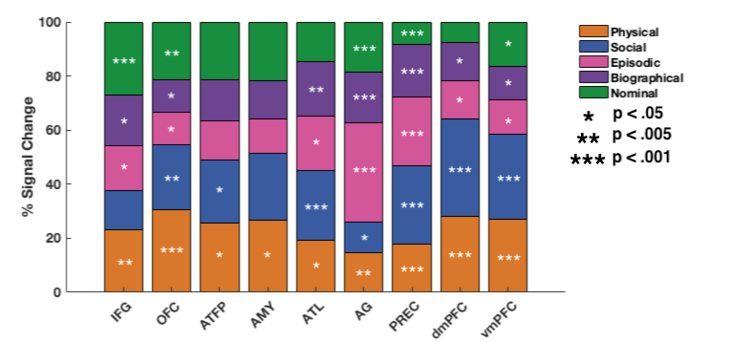

*Figure. Regional preference patterns. Percentage of total activation elicited by each cognitive domain. Stars denote significance (uncorrected) of regional involvement in a specific person-knowledge domain compared to the name-matching baseline condition. Most regions are involved in most cognitive domains, and no brain regions appear to be driven by a single cognitive domain. However subtle patterns can be seen in the variations of loadings of particular domains in different brain regions.*

**Multivariate analyses**

**Structure of person knowledge**

Here we address how different tasks are encoded in across the extended system ROIs. As can be seen in figure two, all tasks elicit activity in multiple regions. Tasks are not localised in a single regions, investigating task differences is then multivariate problem. Formally, we investigate the similarity of activity patterns across the network produced when accessing different kinds of person knowledge. To compute task similarity, we correlate network-level activity patterns for all pairs of tasks. Resulting matrix represent pairwise task similarity in network patterns. Multi-Dimensional Scaling (MDS) procedure allows to visualise multi-dimensional relationships, figure. Based on the distance we can see that some tasks share engage overlapping regions. Social tasks (trustworthiness and friendliness) are grouped together, so are nominal tasks.

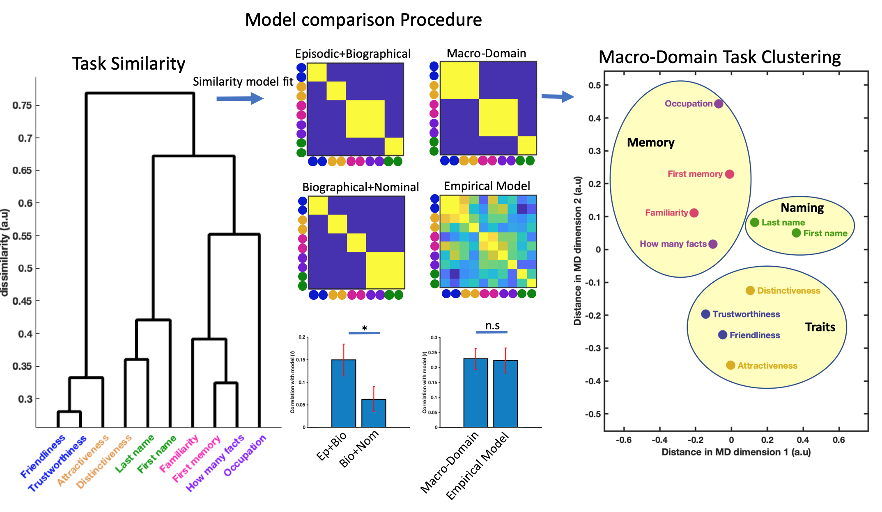

*Figure. Organization of person knowledge.* ***Left****) Dendrogram plot reflecting the similarity in network activation patterns. Tasks that are linked with short paths (e.g. those of ‘trustworthiness’ and ‘friendliness’) signify that patterns across the extended system ROIs during these tasks is similar. Points far apart (e.g. ‘occupation’ and ‘attractiveness’) mean that these tasks elicit different patterns.* ***Middle****) Matrices denote hypotheses about cognitive structure expressed as models of expected similarity. Bar graphs show model fit comparisons. Biographical knowledge is represented more like episodic, than nominal knowledge. Macro domain model explains as much variance as empirical model derived from a face viewing experiment.* ***Right****) Task similarity structure visualized, MDS plot of task similarity with macro-domain clusters overlaid. Suggests that 10 cognitive tasks form three groups of cognitions: social and physical trait judgements, tasks involving retrieval of episodic or biographical knowledge, and tasks involving knowledge about names.*

**Stable patterns in extended, but not core regions**

To investigate whether accessing person-knowledge produces reliable patterns across stimulus modalities within perceptual and extended systems we separately compared pattern stability in the two components. We used patterns of activity during face-cued person knowledge averaged across subjects (N=20) as a model, and correlated it to the patterns in the extended and core components during name-cued person knowledge (for each subject individually). Different cognitive tasks produce reliably similar patterns during face- and name- cued person knowledge in the extended system (t(23) = 5.33,p < 0.001). This is contrast to the core system, where there was no similarity between patterns during face viewing and name reading t(23) = -0.69,p = 0.496.

**Pairs**

We first investigate a simple task pair model. This model assumes that tasks sampled from the same domain of tasks should be more similar to each other than to any other task. No higher order relationships are assumed. Results show a robust fit, task pair model fits the data well t(23) = 5.90,p < 0.001. This validates our tasks selection and serves as a starting point for looking into higher order cognitive similarity  - similarity between cognitive domains of tasks.

Inspecting the dendrogram visually suggests that distinctivess task produced more similar patterns of activity to nominal knowledge tasks, than social or attractiveness tasks. This is incontrast to our previous experiment where we observed distinctiveness coupling tightly with other socio-perceptual judgements in the dendrogram. To see whether this effect is robust, we performed a posthoc analysis. This addressed whether distinctiveness task is more similar to attractiveness or nominal knowledge tasks, figure. We directly compared a task pair model, against a model in which distinctiveness goes with nominal tasks. The effect was not robust, distinctiveness task was not more similar to nominal task than attractiveness task t(23) = 0.16,p = 0.876.

**Biographical and Episodic knowledge share encoding similarity**

To replicate our prior finding that episodic knowledge is more similar to biographical knowledge than nominal knowledge we replicate analysis we did in a previous  experiment. We contrast models in which biographical knowledge is grouped with episodic, against one in which former is grouped with nominal. Results show that biographical knowledge is represented more similarly to episodic knowledge than biographical knowledge, t(23) = 2.89,p = 0.008.

**Task encoding is stable across modalities**

To investigate whether distributed task representation is stable regardless of input modality, we take average task similarity matrix of the face experiment as a model, and compare it against data where names were used as stimuli. Regardless of the differences in the stimuli, face data model shows a robust concordance with name data, t(23) = 5.33,p < 0.001. Moreover, face data predict word data significantly better than pairs model, t(23) = 2.71,p = 0.012 and marginally better than model that incorporates episodic+biographical macro grouping t(23) = 2.06,p = 0.051. This suggest that some variance in the data is not explained by a simple model.

**Simple three cluster model of Person Knowledge**

During face viewing, we observed that cognitive tasks cluster into three macro-domains: Socio-perceptual judgements, episodic and biographical knowledge, and nominal knowledge. We explicitly model this task grouping and see that it outperforms other models, and explains as much variance as the face data itself. Three cluster grouping outperforms pairs model, t(23) = 4.61,p < 0.001 and biographical+episodic model t(23) = 4.50,p < 0.001. There was no difference between the variance explained by face data modal and three cluster model t(23) = 0.18,p = 0.858, suggesting that three clusters explain the data well.

**Groups of similarly tuned regions**

Individual regions have intricate cognitive tunings. To better understand how the co-ordinated regional activity encodes diverse kinds person-knowledge we look at patterns of similarity across cognitive tuning profiles. We group regions according to their response pattern similarity, and look for groups of regions responding similarly across tasks. Groups of regions recruited in similar circumstances likely perform similar functions. We visualise regional similarity structure by computing a dendrogram, and fit competing RSA models of regional similarity to test hypotheses about network organisation.

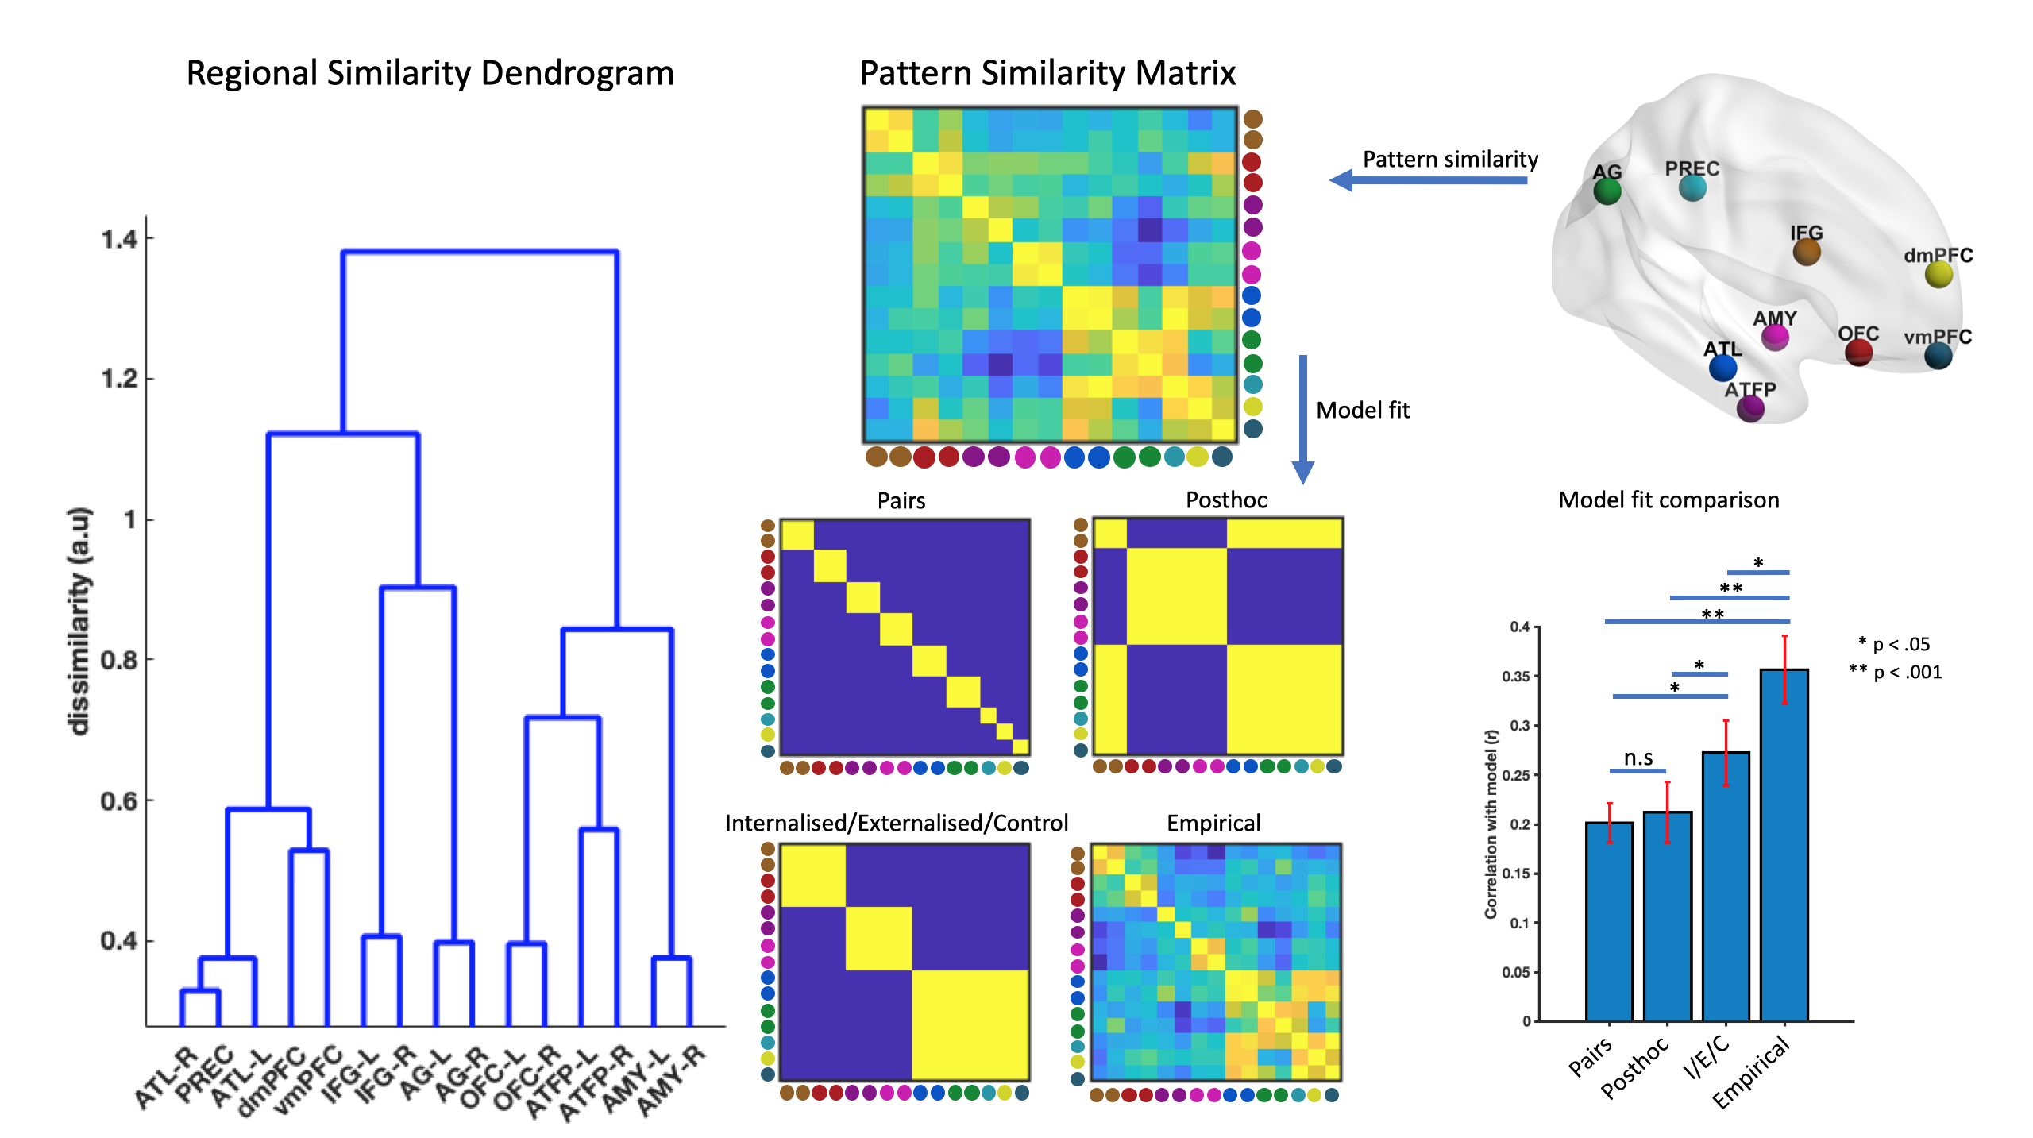

*Figure. Regional similarity. Left) Dendrogram of showing the clustering of cognitive tuning profiles. First major division in the dendrogram separates internalised cognition regions and IFG from externalised and OFC. Right) We fit competing models of regional structure to the data. This analysis revealed that the most reliable division if between internalised and externalised cognition regions.*

To test competing models of regional organisation we compare the fit of different RSA models. We first fit a simple pairs RSA model to test whether hemispheric homologues share cognitive tuning, we then extend the model by looking whether broader groups of regions share additionally informative response similarity.

**Modelling network structure**

We first fit a pairs model, hypothesising that response patterns between inter-hemispheric homologues should be more similar, and medial regions should provide independent contributions. This model proves robust t(23) = 10.26,p < 0.001, hemispheric homologues have similar cognitive profiles. Next, we extend this model to investigate whether groups of regions form higher order clusters. Building on previous findings that regions involved in internalised cognition cluster separately from amygdala and ATFP, as well as separately from IFG and OFC we build a three cluster model (figure). We build a similarity model which reflects observed clustering, i.e. IFG+internalised cognition regions vs Amygdala, ATFP & OFC (posthoc model). Results show that regions involved in control (IFG, OFC), internalised cognition (PREC, AG, ATL, dmPFC & vmPFC) and externalised cognition (AMY, ATFP) form separate clusters. Three part model outperforms both pairs t(23) = 2.14,p = 0.043, and posthoc models t(23) = 2.62,p = 0.015. Empirical model derived from the face data experiment outperforms the three-cluster model t(23) = 3.75,p = 0.001, suggesting that while informative, this model does not capture all significant relationships.

**Discussion**

**Bullet Points**

* Person knowledge is represented across multiple regions of the extended system (univariate results, stacked bar), regions respond to multiple cognitions, with a cognitively tuned response
* Person knowledge forms elicits different patterns of activity across the network, and clusters into three groups - socio-perceptual judgements, episodic-semantic memory recall, nominal knowledge retrieval.
* Overall, similar structure of person-knowledge representation whether we look at faces or read names. Three cluster model explains a similar amount of variance as the empirical model, so it's a meaningful model.
* Spend a couple of sentences discussing disctintiveness: clusters with nominal rather than physical in word data, but not significantly better, maybe some tasks are more sensitive to stimulus than others.
* Regions cluster into groups, previously associated with externalised/internalised cognition and semantic control (I/E/C) model,
* Fine-scale regional interactions, beyond broad grouping is also important (better fit of empirical than IEC)

This paper investigated the structure of person-knowledge representation during name reading. We show that 1) distinct person-knowledge tasks form clusters of similarly represented cognitions, broadly falling into three categories: Memory, Naming and Socio-perceptual judgements. 2) Regions respond to multiple person-knowledge domains, with a preferential response to some. 3) Regions group into functional units, commonly responding to person-knowledge tasks.

2) Different types of person-knowledge are represented similarly across modalities of input (faces, names). 3)

**Cognitive structures**

* Coordinated activity across multiple regions
* Three clusters, stable across stimulus domains
* Conceptual representation of person knowledge, not face

**Person knowledge is distributed across the extended system**

How is person knowledge represented? Retrieving various attributes associated with a person involves coordinated activity of multiple brain regions (Haxby et al 2007; Fairhall & Caramazza 2013). Whether different person-attributes attributes are represented in distinct or overlapping neural questions is a matter of debate. Some suggest that different types of knowledge are represented in specialised regions, and bound-together in a hub region, located in the ATL (Patterson et al 2007; Patterson et al 2017; Wang .. Olson, 2017). However, since most-all regions of the extended system are spontaneously recruited, even during relatively simple 1-back matching tasks (Todorov, Gobbini et al, 2007) establishing specific regional contributions (‘regional roles’) has been challenging. To side-step this issue - in the present work, we asked participants to recall diverse types of person-knowledge. We reasoned that if a region performs a key function to a single cognitive domain, and is only incidentally active for others - we would expect to see a strong preference for a single cognition. Instead, we observed that most-all regions are involved in most-all tasks, with subtle cognitive tunings. Our results strongly suggest, that different kinds of person-knowledge are represented in a distributed fashion across overlapping neural substrates in the extended system. To investigate the distributed representation of person knowledge, we used multivariate tools, relating network-level patterns of activity across different tasks.

**Person knowledge structure**

Recent advances in computational techniques (RSA) has allowed to investigate similarities of groups of brain patterns. These techniques allowed researchers to demonstrate that object concepts are organised hierarchically by their taxonomic similarity (Fairhall & Caramazza, 2013). However, person knowledge does not have a pre-defined, taxonomic structure. In this paper, as well as in Aglinskas & Fairhall (2019), we therefore invert standard RSA framework, and infer of person-knowledge structure from clustering of brain-patterns. We clustered network level patterns to demonstrate that seemingly different cognitions form three prominent clusters: socio-perceptual trait judgements, episodic/semantic memory retrieval & nominal knowledge. These macro-domains fall broadly within hypothesised domain-specificity boundaries (Spunt and Adolphs 2017) suggesting that declarative memory (episodic, semantic tasks) and language (nominal tasks) are part of the ‘cognitive’ macro-domain, while facial reception (physical tasks) and theory of mind (social tasks) are part of the ‘social’ macro-domain.

**Stable**

Importantly, comparing data from two experiments we further show that organisation of person knowledge into macro domains is replicable in a new group of subjects & is independent of perception. This suggests that present findings reflect organisation of conceptual knowledge, independent of the stimulus - expanding prior work. Previous work has shown that famous face and famous name stimuli rely on partially overlapping neural substrates (Gorno-tempini 1996; Nielsen, 2009). Question remained whether these regions, when active, perform different functions based on the stimulus modality. Results from the current experiment, showed that the representation of person knowledge within the extended system remains similar during name reading and face viewing - suggesting conceptual, rather than perceptual processes.

* ~~Episodic and Biographical~~

~~One of the major distinctions is cognitive psychology (Tulving). Both involve memory access~~

* ~~Social and Physical~~

~~Social and Physical knowledge, Seemingly different cognitions, cluster together in the wild, attractive people are rated as more friendly. Both are also more subjective (transient, trait based, can change).~~

* ~~Social and physical knowledge clustering comes with a caveat~~

~~It is possible that social and physical knowledge are more different than we presented here. Attractiveness task clusters close to Friendliness and Trustworthiness, but is also quite a social judgement. More ’purely’ physical judgement - distinctiveness, was less strongly correlated with the rest, evidence for distinctiveness going with attractiveness or common name was equal.~~

~~Future research, selecting more prototypically social and physical tasks can further delineate the similarity of how these tasks are represented.~~

~~Nominal knowledge is a special type of cognition. Recalling someone’s name is unlike recalling other types of facts about them. Naming is known to recruit a different topography of brain regions (ref). Patients can be selectively impaired on naming tasks, but not show effects in fact recall (). Therefore it makes sense that nominal knowledge is activated a network differently than other tasks.~~

* Generality of three clusters?

How these clusters generalise is unclear. Future research investigating different kinds of person knowledge can investigate even larger clustering of person knowledge. for example whether all trait inferences (OCEAN) are represented similarly in the brain.

**Regional similarity**

In this work we demonstrated that regions involved in person knowledge form groups of similarly behaving regions: Internalised/Externalised/Control

**Conclusion**

In summary, this paper shows that diverse kinds of person-knowledge are represented in distributed and overlapping neural substrates in the extended system for person-perception. Memory processes, Nominal knowledge retrieval and trait inferences recruit this network in distinct topographies. Name and face-cued person-knowledge is represented in largely the same way. Regions of the extended system form functional units of similarly behaving regions: DMN, internalised and externalised cognition regions.